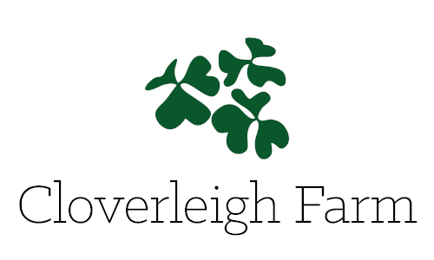

Business plan excerpt

Small sustainable farms, using organic practices, are part of the next wave of farming in America. According to the Organic Trade Association, consumer demand for organic products has grown by double-digits every year since the 1990’s. Organic sales have increased from $3.6 billion in 1997 to over $39 billion in 2014, which includes $35.9 billion in organic food sales, an 11% rise from the previous year. The desire for farm-fresh vegetables consistently grows as people become more educated and aware of the impact of food on their health and wellbeing. Small farms feed the local economy by providing food to those in their community and protecting open space with agricultural value. CSA farms also help to create a sense of community where it is often lacking, by bringing together individuals and families who place a strong value on the importance of farmland and connecting on an intimate level to the person who grows their food. These bonds between producer and consumer create a solid partnership that promotes a vibrant local food system.

Using the knowledge and skills gained from previous work experience on both medium and small-sized mixed vegetable and livestock farms, combined with connections to service providers in the industry, I am poised to begin and grown a farm business in Connecticut. Using a CSA model will provide me with working capital before the season has begun so that all the necessary supplies and equipment can be purchased and seasonal labor can be hired. The financial stability the CSA model provides, coupled with direct sales to restaurants, local universities and food cooperatives, will allow the business to maintain a healthy income balance.

The mission of Cloverleigh Farm is to provide an example of healthy and sustainable vegetable production while support a vibrant local community and economy. Through the inherent values found in small-scale sustainable agriculture, the goal of the business will be to produce fresh and flavorful vegetables and create a long-term financially viable business. My love of farming, desire to work the land, and gratification of growing food for my local community all contribute to my aspirations for my own business.

